ASSIGNMENT – 7.3
2303A51396

Task 1: Fixing Syntax Errors
Scenario
You are reviewing a Python program where a basic function definition contains a syntax error.
Requirements
Python
def add(a,b)
return a + b
• Provide a Python function add(a, b) with a missing colon
• Use an AI tool to detect the syntax error
• Allow AI to correct the function definition
• Observe how AI explains the syntax issue
Expected Output
• Corrected function with proper syntax
• Syntax error resolved successfully
• AI-generated explanation of the fix.
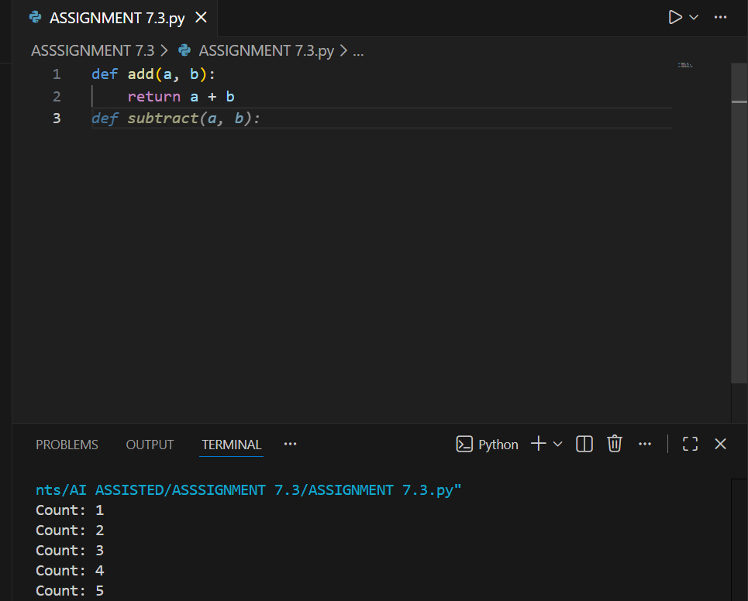

2. Task 2: Debugging Logic Errors in Loops
Scenario
You are debugging a loop that runs infinitely due to a logical mistake.
Requirements
• Provide a loop with an increment or decrement error
• Use AI to identify the cause of infinite iteration
• Let AI fix the loop logic
• Analyze the corrected loop behavior
Expected Output
• Infinite loop issue resolved
• Correct increment/decrement logic applied
• AI explanation of the logic error

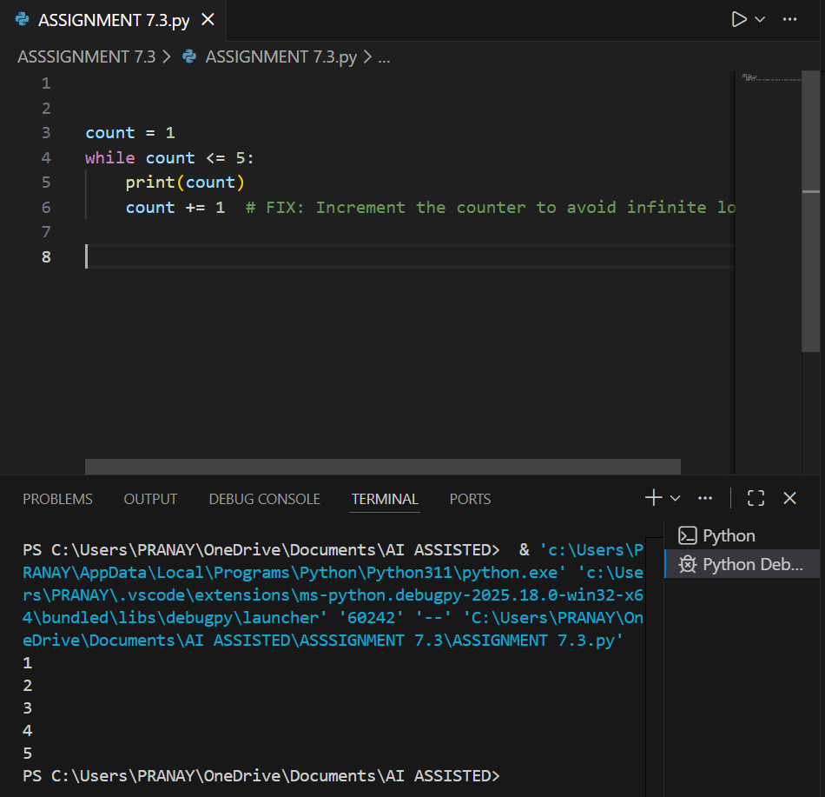

Task 3: Handling Runtime Errors (Division by Zero)
Scenario
A Python function crashes during execution due to a division by zero error
Requirements
• Provide a function that performs division without validation
• Use AI to identify the runtime error
• Let AI add try-except blocks for safe execution
• Review AI’s error-handling approach
Expected Output
• Function executes safely without crashing
• Division by zero handled using try-except

• Clear AI-generated explanation of runtime error handling
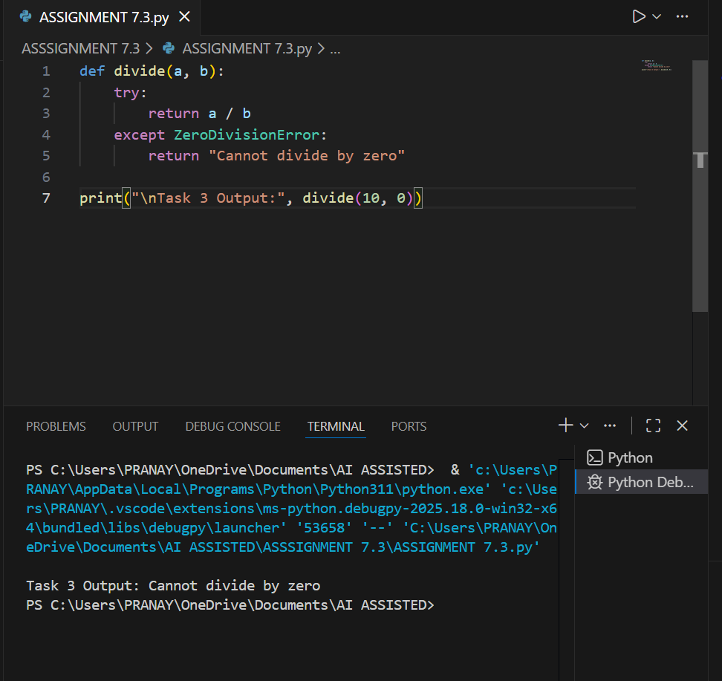

4. Scenario
You are given a faulty Python class where the constructor is incorrectly defined.
Requirements
• Provide a class definition with missing self-parameter
• Use AI to identify the issue in the __init__() method
• Allow AI to correct the class definition
• Understand why self is required
Expected Output
• Corrected __init__() method
• Proper use of self in class definition
• AI explanation of object-oriented error
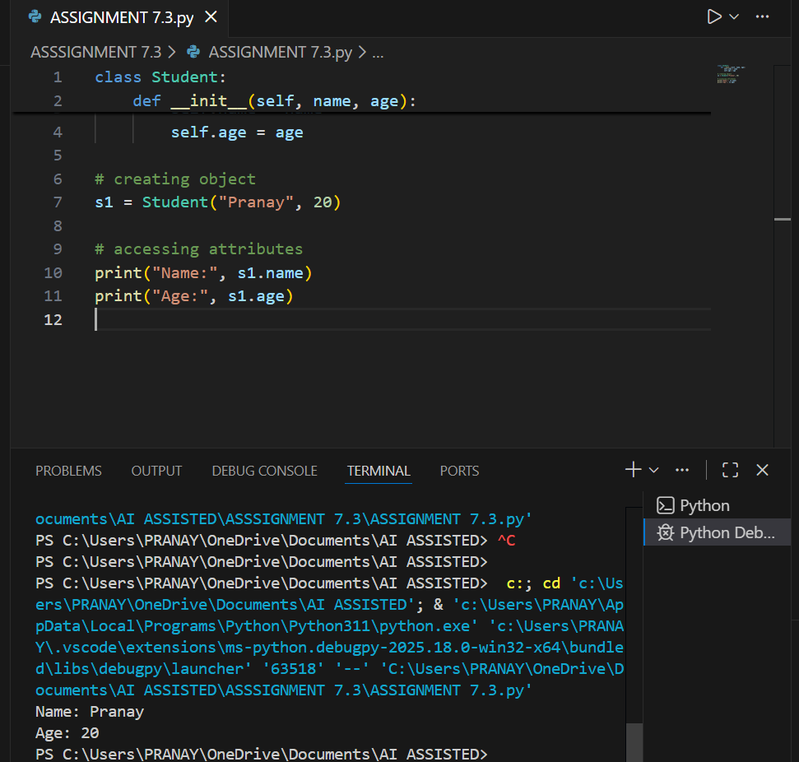

5. Task 5: Resolving Index Errors in Lists
Scenario
A program crashes when accessing an invalid index in a list.
Requirements
• Provide code that accesses an out-of-range list index
• Use AI to identify the Index Error
• Let AI suggest safe access methods
• Apply bounds checking or exception handling
Expected Output
• Index error resolved
Safe list access logic implemented
• AI suggestion using length checks or exception handling
